SYSTEM WORKFLOW
Video-Based Pose Correction Pipeline (Current Live System)
Date: 16th June 2026

1. Overview
This document describes the system workflow of the live, video-based pose correction pipeline as it currently runs in the application. The workflow takes a user's webcam feed, detects body landmarks with MediaPipe, extracts a feature vector, classifies the user's current pose step, and produces real-time corrective feedback (including coaching from a local LLM).
The IMU sensor pipeline described elsewhere is not part of this workflow. It is a separate, ready-but-awaiting-implementation module that is not yet wired into the steps below; everything in this document reflects only what is live today.
Figure 1 below shows the seven stages of the pipeline in sequence, with the data passed between stages labelled on each arrow, and the two-part stages (feature extraction, step classification, and feedback generation) broken out into their constituent sub-modules. Each stage is described in Section 3, followed by an “Algorithm” written in the same Inputs / Output / while-loop pseudocode style as the reference paper, with formulas given inline and variable definitions on “where” lines.

2. System Workflow Diagram
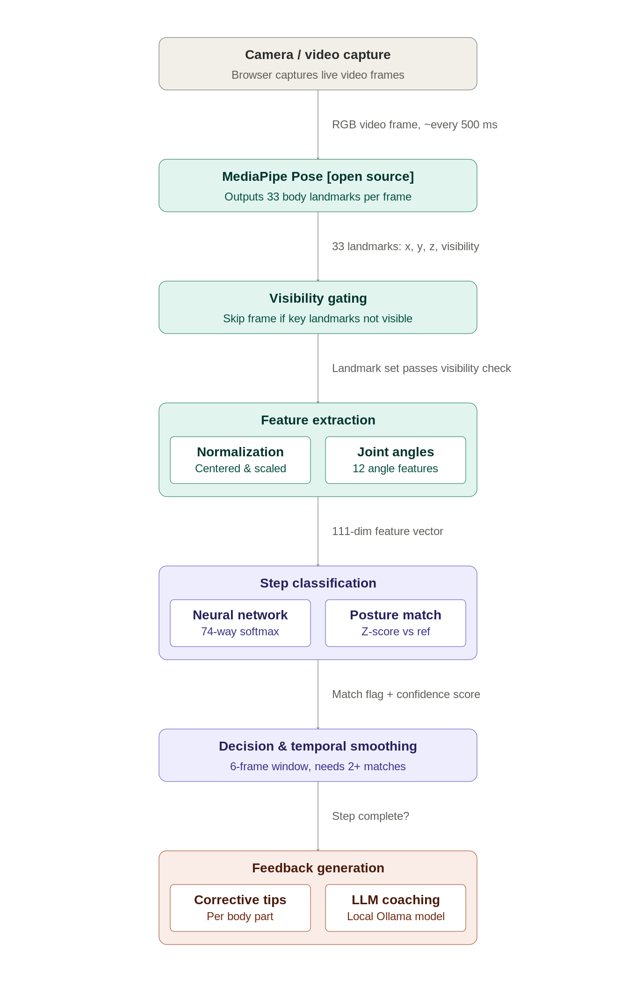
Figure 1. Proposed system workflow (video-based pipeline, sensor module excluded).

3. Workflow Modules

3.1 Camera / Video Capture
The browser captures the user's live webcam feed and makes frames available to the rest of the pipeline at a fixed sampling rate.
Algorithm:
Inputs:
- Raw camera stream from the browser's media-device API
Output:
- RGB video frame Fₜ, sampled at interval Δt ≈ 500 ms
camera permission granted
Step-1: Render the live video stream to an on-screen video element so the user can see themselves;
Step-2: Every Δt, capture the current video frame Fₜ;
Step-3: Pass Fₜ to the MediaPipe Pose module;
end

3.2 MediaPipe Pose Detection
MediaPipe Pose runs on each sampled frame in the browser and produces a full-body landmark skeleton, which is the raw input to all later stages.
Algorithm:
Inputs:
- RGB video frame Fₜ
Output:
- Landmark set L = {P₀, …, P₃₂}, where Pᵢ = (xᵢ, yᵢ, zᵢ, vᵢ) and vᵢ is the visibility score
frame Fₜ received
Step-1: Run the MediaPipe Pose model [open-source] on Fₜ;
Step-2: Obtain 33 body landmarks Pᵢ = (xᵢ, yᵢ, zᵢ, vᵢ), i = 0…32;
Step-3: Pass L to the onPoseResults callback for downstream processing;
end

3.3 Visibility Gating
Before any landmark is used for classification or feedback, the pipeline checks that the body parts it actually cares about are clearly visible. This prevents the system from confidently (and wrongly) marking an occluded or out-of-frame pose as “correct.”
Algorithm:
Inputs:
- Landmark set L
- Visibility threshold τ = 0.5
- Visibility-critical set V = {11, 12, 23, 24, 25, 26, 27, 28} (shoulders, hips, knees, ankles)
Output:
- Gated landmark set L, or a skip signal for frame Fₜ
L received
Step-1: For each i ∈ V, read visibility vᵢ from L;
if (∃ i ∈ V : vᵢ < τ) then
skip frame Fₜ — no classification or feedback is generated;
end
Step-2: else, pass L to feature extraction;
end

3.4 Feature Extraction
Raw landmark coordinates are converted into a normalized, scale- and position-invariant feature vector that the classifier was trained on, plus a set of joint-angle features that capture body posture directly.
Algorithm:
Inputs:
- Gated landmark set L = {P₀, …, P₃₂}, Pᵢ = (xᵢ, yᵢ, zᵢ)
Output:
- 111-dimensional feature vector F
L received
Step-1: Normalize landmarks;
(a) Hip midpoint:
H = (P₂₃ + P₂₄) / 2;
(b) Shoulder midpoint:
S = (P₁₁ + P₁₂) / 2;
(c) Scale:
s = ‖S − H‖; if s < 1e-6 then s = 1;
(d) Normalize each landmark:
Pᵢ′ = (Pᵢ − H) / s, for i = 0…32;
where Pᵢ′ is the centered, scale-invariant landmark; the 33 normalized landmarks are flattened into Fₙ ∈ ℝ⁹⁹;
Step-2: Compute joint-angle features;
(a) Vertex angle (left/right elbow, knee, hip, shoulder, ankle):
θ = arccos( (BA · BC) / (‖BA‖ ‖BC‖) ), BA = A − B, BC = C − B;
where A, B, C are the three landmarks defining the joint and B is the vertex (e.g. shoulder–elbow–wrist for the elbow angle);
(b) Axis-relative angle (spine tilt, shoulder-line tilt):
θ = arccos( (v · a) / (‖v‖ ‖a‖) );
where v is the relevant body-segment vector and a is the fixed reference axis; together the 12 angles form Fₐ ∈ ℝ¹²;
Step-3: Concatenate:
F = Fₙ ⊕ Fₐ, |F| = 111;
end

3.5 Step Classification
A trained neural network classifies which “step” of the current pose the user is performing, restricted to the steps that belong to the pose the user has selected.
Algorithm:
Inputs:
- Feature vector F ∈ ℝ¹¹¹
- Selected pose P, with step-class set steps(P) ⊆ {1, …, 74} and expected step e ∈ steps(P)
Output:
- expectedScore, poseScoreSum, classifierIsMatch
F received
Step-1: Run the network (NN) and apply softmax:
y = softmax(NN(F)), y ∈ ℝ⁷⁴;
where NN = Dense(256, ReLU) → Dropout(0.3) → Dense(128, ReLU) → Dropout(0.2) → Dense(64, ReLU) → Dense(74);
Step-2: Restrict candidates to the current pose's steps {yᵢ : i ∈ steps(P)};
Step-3: Read off the expected step's score and the total score across the pose's steps:
expectedScore = y_e; poseScoreSum = Σ_{i ∈ steps(P)} yᵢ;
Step-4: Determine classifier match:
classifierIsMatch ⇔ ( e = argmax_{i ∈ steps(P)} yᵢ ) ∨ ( y_e ≥ 0.85 · max_{i ∈ steps(P)} yᵢ );
end

3.6 Posture Descriptor Matching
Alongside the neural network, a second, interpretable check compares the user's raw joint angles and body measurements against reference statistics collected for each step, acting as a sanity check on the classifier.
Algorithm:
Inputs:
- Raw landmarks L
- Reference statistics {medianᵢ, MADᵢ} for the expected step e, from step_reference_stats.json
- Feedback z-threshold = 1.6; descriptor match threshold = 0.7
Output:
- descriptorMatchScore, descriptorIsMatch
L received
Step-1: Compute descriptors xᵢ — the 12 joint angles plus foot separation, knee separation, left/right wrist height, and left/right wrist-to-shoulder distance — excluding SKIP_DESCRIPTORS;
Step-2: For each descriptor i, compute the deviation from the reference:
spreadᵢ = max(MADᵢ, floorᵢ); zᵢ = (xᵢ − medianᵢ) / spreadᵢ;
where floorᵢ = DESCRIPTOR_STD_FLOOR[i], or 0.2 for angle descriptors and 0.05 otherwise;
Step-3: Compute the overall match score:
descriptorMatchScore = | { i : |zᵢ| < 1.6 } | / | {i} |;
Step-4: Determine descriptor match:
descriptorIsMatch ⇔ descriptorMatchScore ≥ 0.7;
end

3.7 Decision Logic and Temporal Smoothing
The classifier result and the posture descriptor result are combined into a single per-frame decision, and that decision is smoothed over a short rolling window of frames so that a single noisy frame cannot flip the result.
Algorithm:
Inputs:
- classifierIsMatch, descriptorIsMatch, expectedScore, poseScoreSum, descriptorMatchScore
- Rolling window W of the last 6 processed frames (≈ 3 s at Δt ≈ 500 ms)
Output:
- stepComplete
new frame result available
Step-1: Combine the two signals:
isMatch = classifierIsMatch ∨ descriptorIsMatch;
Step-2: Compute the strongest confidence signal:
matchConfidence = max( expectedScore / poseScoreSum , descriptorMatchScore );
Step-3: Append (isMatch, matchConfidence) to W; if |W| > 6, drop the oldest entry;
Step-4: Count frames meeting both criteria:
c = | { f ∈ W : isMatch_f ∧ matchConfidence_f > 0.25 } |;
Step-5: Decide step completion:
stepComplete ⇔ ( |W| = 6 ) ∧ ( c ≥ 2 );
end

3.8 Feedback Generation
When the user is not matching the expected step, the system generates two layers of feedback: an immediate body-part-specific correction, and — if the user remains stuck — a more detailed coaching tip from a local language model.
Algorithm:
Inputs:
- Per-descriptor deviations zᵢ (from Section 3.6) and the DESCRIPTOR_FEEDBACK phrase map
- Tunmatched = time since the user last matched the expected step; threshold = 3 s, cooldown = 10 s
Output:
- Corrective text for the user, and (optionally) an LLM coaching tip
stepComplete = false
Step-1: Flag and rank deviations:
flagged = { i : |zᵢ| ≥ 1.6 }, sorted by |zᵢ| descending;
Step-2: Take the largest deviation and map it to a phrase:
top = flagged[0]; phrase = DESCRIPTOR_FEEDBACK[top].low if z_top < 0, else .high;
display phrase to the user immediately (e.g. “straighten your left knee”);
if (Tunmatched > 3 s ∧ (time since last coaching request) ≥ 10 s) then
if a snapshot image is available, send it to a local vision model [open-source] (llava / moondream) with a vision prompt;
else send the 33-landmark data to a local llama3.2 model [open-source] with a step-verification prompt;
end
Step-3: Parse the model's JSON response (fall back to extracting the first valid JSON object in the text) and display the resulting coaching tip;
end

4. Feature Set and Classification Summary

4.1 Input Features
Each processed frame is represented by a 111-dimensional feature vector made up of two parts:
- 99 normalized landmark coordinates — the (x, y, z) positions of all 33 MediaPipe body landmarks, after centering on the hip midpoint and scaling by torso length (see formulas in Section 3.4). This makes the features independent of where the user stands and how far they are from the camera.
- 12 joint-angle features — left/right elbow, knee, hip, shoulder, and ankle angles, plus spine tilt and shoulder-line tilt, computed directly from the raw landmark positions.
A related but separate set of posture descriptors (the 12 joint angles plus foot separation, knee separation, wrist heights, and wrist-shoulder distances) is computed for feedback purposes only and is not fed into the classifier.

4.2 How Classification Works
- The 111-dimensional feature vector is passed through a TensorFlow.js feedforward neural network: Dense(256, ReLU) → Dropout(0.3) → Dense(128, ReLU) → Dropout(0.2) → Dense(64, ReLU) → Dense(74, softmax).
- The 74 output classes correspond to individual “steps” spread across the 13 supported poses (e.g. multiple steps per pose, such as entering, holding, and adjusting a posture).
- For a given frame, only the step classes belonging to the user's currently selected pose are considered as candidates — the model's full 74-way output is filtered down to that pose's steps before deciding whether the user is on the expected step.
- A frame is treated as a match for the expected step either when the classifier itself picks that step as most likely (or very close to it), or when the posture descriptor check independently confirms the user's joint angles and body measurements are close enough to the reference values for that step — whichever signal agrees first counts as a match (see Sections 3.5–3.7 for the exact formulas).
- Because a single frame can be noisy, the final “step complete” decision is smoothed over a rolling window of the last 6 frames (about 3 seconds), requiring at least 2 of those frames to be matches before the system advances the user to the next step.
- The current (v5) model was trained on 56,448 samples and validated on 9,962 samples, reaching a validation accuracy of 81.68% across all 74 step classes.
Note: This workflow intentionally excludes the IMU sensor pipeline. The sensor-based pose pipeline is built and tested separately and is ready but awaiting implementation — it does not affect any of the stages described above.

